MEASURING THE PULSE OF PROSPERITY: AN INDEX OF ECONOMIC FREEDOM ANALYSIS

1. Introduction

1.1 Overview

Economic freedom is the fundamental right of every human to control his or her own labor and property. In an economically free society, individuals are free to work, produce, consume, and invest in any way they please. In economically free societies, governments allow labor, capital, and goods to move freely, and refrain from coercion or constraint of liberty beyond the extent necessary to protect and maintain liberty itself. For much of human history, most individuals have lacked economic freedom and opportunity, condemning them to poverty and deprivation.

1.2. Purpose

Today, we live in the most prosperous time in human history. Poverty, sicknesses, and ignorance are receding throughout the world, due in large part to the advance of economic freedom. In 2022, the principles of economic freedom that have fueled this monumental progress are once again measured in the Index of Economic Freedom, an annual guide published by The Heritage Foundation, Washington's No. 1 think tank.

1. PROBLEM DEFINITION & DESIGN THINKING

* 1. Empathy Map

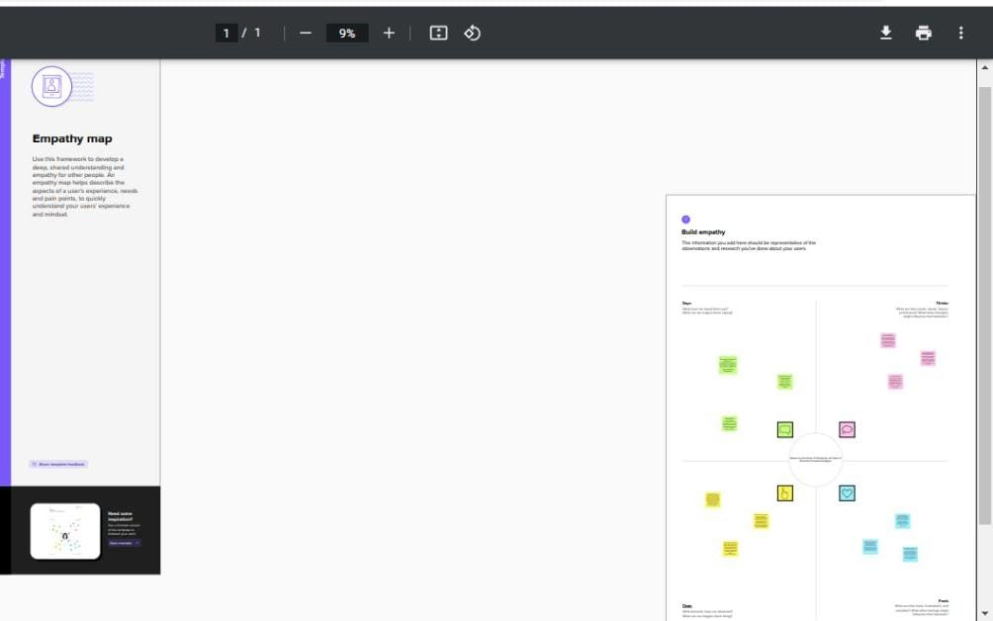

* 1. Ideation & Brainstorming Map

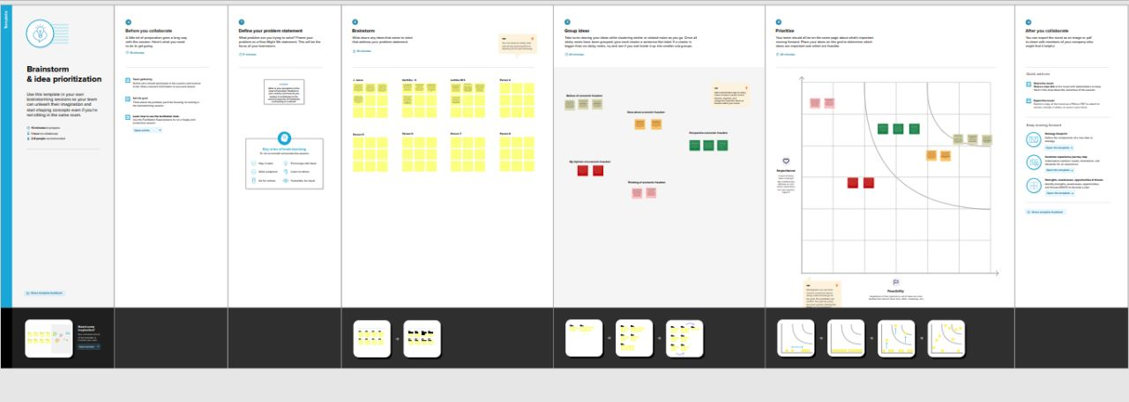

1. RESULT

The hypothesis that economic freedom and related variables are significant determinants of real per capita income and growth is critically evaluated. Economic freedom is found necessary for higher levels of per capita income and growth largely in terms of threshold effects as opposed to persistent marginal effects. More economic freedom does not appear to yield higher levels of per capita income. And securing particular levels of economic freedom does not guarantee higher levels of per capita income or growth. Secure private property rights is found to be a most significant positive causal variable as is sound money, whereas moderate amounts of labor regulation and big government are not found to be bad for the economy. Also, good corporate governance, in addition to economic freedom, is of considerable import. Unlike most studies, traditional statistical methods are supplemented by graphical analysis in an effort to determine threshold values for economic freedom and its components.

1. ADVANTAGES & DISADVANTAGES

Advantages

The benefits of a market economy include **increased efficiency, production, and innovation**. The disadvantages of a market economy include monopolies, no government intervention, poor working conditions, and unemployment.

Disadvantages

**The lack of government control allows free market economies a wide range of freedoms, but these also come with some distinct drawbacks.**

1. APPLICATIONS

1. Labor Freedom- This is measure of a country’s legal and regulatory framework as it applies to the labor market. The easier individuals can move in and out of occupations, the more efficiently labor moves to more productive and higher valued work. There are 6 equally weighted factors in this component: a. Ratio of minimum wage to the average value added per worker b. Hindrance to hiring additional workers c. Rigidity of hours d. Difficulty of firing redundant employees e. Legally mandated notice period

2. Financial Freedom- This is a measure of banking security and the independence from government control. The idea is that state ownership of banks and other financial institutions such as insurers and capital markets is an inefficient manner to regulate capital that reduces competition and generally lowers the level of available services. The scoring is synonymous to that of investment freedom, using criteria such as the extent of state intervention in banks and other financial services, government influence on the allocation of credit, and the difficulty of opening and operating financial services firms.

3. Government Size- This component is straight-forward and uses the level of government expenditures as a percentage of GDP, and this includes government consumption and transfers. They state that some level of government expenditures represents true public goods, which would imply an ideal level greater than zero, but they believe it is too difficult to apply universally. Also, there are few countries, if any, that are below this level. Therefore, they treat zero government spending as the benchmark. Government expenditures necessarily compete with private agents and interfere in market prices by over-stimulating demand and potentially diverting resources through a crowding-out effect

4. Monetary Freedom- Price stability and an assessment of price controls are combined to measure monetary freedom. Price stability without microeconomic intervention is the ideal state for the free market. The 2 inputs are as follows:

a. The weighted average inflation rate for the most recent three years

b. Price controls

5. Freedom from Corruption- This component is derived for most of the countries by using the Transparency International’s Corruption Perceptions Index (CPI), which gives a score of 0 to 10 and then they convert it over to the 0 to 100 scale. The idea with corruption is simply that the more it exists the more it erodes economic freedom by introducing insecurity and uncertainty into economic relationships.

1. CONCLUSION

Economic growth is the continuing increase in the volume of production in one country, ie. GDP growth, while economic development is not only quantitative but also qualitative changes that lead to better meet their needs. Economic development is associated with the accumulation of capital, ie. with investments. Under the capital we mean permanent production goods that serve as a work tool in the production of other goods. Under the concept of investment we mean investing in fixed and revolving funds, that is. the part of the social product that is not spent, but it is used for replacement and construction of new capacity

1. FUTURE SCOPE

Economic growth **creates higher tax revenues, and there is less need to spend money on benefits such as unemployment benefit**. Therefore economic growth helps to reduce government borrowing. Economic growth also plays a role in reducing debt to GDP ratios

1. APPENDIX

A.Source code

https://en.wikipedia.org/wiki/Index_of_Economic_Freedom